UNIVERSITY OF ENGINEERING AND TECHNOLOGY TAXILA
DEPARTMENT OF INDUSTRIAL ENGINEERING
(Mid semester examination)
Subject: Engineering Mechanics Semester: 3rd Semester 2013
Time Allowed: 2.0 hours Max Marks: 20

Q1 | Fill in the blanks  15 Slug = ________________Kg  20 ft = _________________ m  33 lb = ___________________N  29 pound mass = _______________ Kg | 2
Q2 | A). Determine the x and y components of each of the forces shown.  B). Knowing that α = 55º and that boom AC exerts on pin C a force directed along line AC, determine (a) the magnitude of that force, (b) the tension in cable BC.  Fig: Q2 (A) Fig: Q2 (B) | 6
Q3 | A). Cable AC is 70 ft long, and the tension in that cable is 5250 lb. Determine (a) the x, y, and z components of the force exerted by the cable on the anchor C, (b) the angles ux, uy, and uz defining the direction of that force.  B). A frame ABC is supported in part by cable DBE that passes through a frictionless ring at B. Knowing that the tension in the cable is 385 N, determine the components of the force exerted by the cable on the support at D.  Fig: Q3 (A) Fig: Q3 (B) | 6
Q4 | A). A transmission tower is held by three guy wires attached to a pin at A and anchored by bolts at B, C, and D. If the tension in wire AB is 630 lb, determine the vertical force P exerted by the tower on the pin at A.  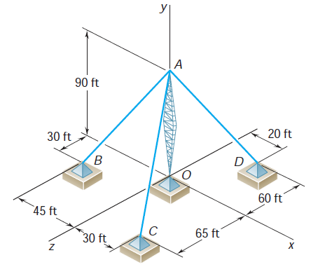  B). A cube of side a= 15cm is acted upon by a force P as shown. Determine the moment of P (a) about A, (b) about the edge AB, (c) about the diagonal AG of the cube.  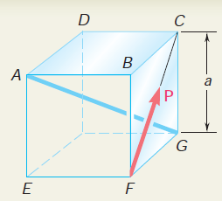 | 6

